SAF-Teso ANNUAL REPORT
2016/2017
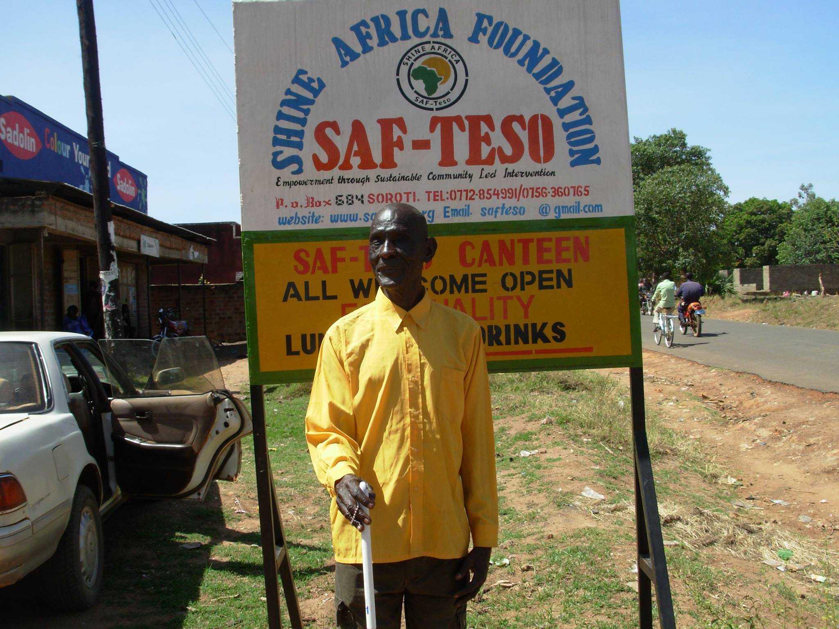

MESSAGE FROM THE PROGRAMA COORDINATOR
Dear Friends, Partners and Key stakeholder of SAF-TESO Services,

The number of blessings we have at SAF-Teso is infinite.
It would take an entire library to document them all, but none would be more important than our number 1 blessing—you.

It is my great pleasure to share with you some of the many ways in which SAF-TESO Services has fulfilled its mission to serve as a catalyst for change, supporting individuals and families by providing excellent community services to overcome the impact of poverty and disease.

During the past year, our organization served 5,250 individuals and families with an emphasis on activities that focus on reduced impact of poverty and prevalence of disease, particularly HIV infection among the population. It has been a privilege to witness the countless ways in which the support of many friends like you have helped this organization make lasting change in the lives of the poor segment of our society. I thank you, and ask for your continued support.

Faithfully,

______________________
Naturinda Lehema
PROGRAMS COORDINATOR

MESSAGE FROM THE EXECUTIVE DIRECTOR

I have been blessed to serve as executive director of SAF-Teso over the past years, working with 9 other staff members who volunteer their time and expertise. It has been our responsibility to ensure that SAF-Teso programs effect positive change in the lives of individuals and families through high-quality services that are provided at a sustainable cost.
Focusing on long-term effects for our target beneficiaries, the community and the organization, the Board and senior leadership staff members created a Strategic Plan for 2012–2014, outlining six key goals that shaped much of the work over the past year. I can now report significant success in all the six (6) areas.

Provision of Excellent Service to Children, Youth, Families and Seniors was reviewed by the Board through internal and external audits. Additionally, Board members were given the opportunity to meet with those served by SAF-TESO for conversations about their experiences, the impact of programs on their lives, and suggested areas for improvement.
Expansion in Service and in Geography is evident in the increased number of individuals served, hours of operation, and communities reached. The careful, controlled growth recommended by the Board has continued with the addition of another 2 new program sites (Ngora and Serere Districts ) in Teso sub-region in 2016/17.
Enhancement of Brand Recognition of SAF-TESO, as well as securing Diverse and Sustainable Financial Resources, has been realized through the work of Emitu Joseph and Okello Joseph, our new Grant Manager and Grant writer of Advancement. The first HIV combination prevention and control project submitted to TASO and the private sector foundation fish cage projects are examples of new ways Emitu and Okello and their SAF-Teso team members have told and celebrated the stories of SAF-TESO, and created opportunities for the larger community to meaningfully support our mission.
Enhancement and Expansion of Community Partnerships have provided significant additional resources for all those served by SAF-TESO. Collaborations have brought to our clients access to numerous complementary services, as do close ties with corporations. In June, Board members worked side by side with a wide range of volunteers during to transform our communities.
Efficiency and Effectiveness of Operations have required regular Board review of policies and systems, maintaining standards of best practices in policies, and streamlining systems to keep them updated and cost effective. I appreciate the work of the Board and Staff that has sustained our organization during a challenging year (2016-2017).

_______________________
Anguria Michael
EXECUTIVE DIRECTOR
SAF-TESO

SAF-Teso 2017 MANAGEMENT TEAM
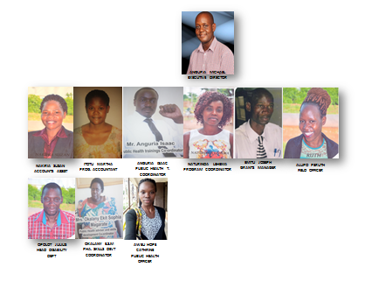

KEY ACTIVITIES

SAF-Teso Community Events

“CELEBRATING COMMUNITY COMMITMENT” AUGUST 2016
On August 7, 2016, SAF-Teso hosted its 3rd Annual Celebrating Community Commitment event honoring key community stakeholders, who were selected because of their leadership, dedication and participation in improving the quality of social programs in geographical areas where SAF-Teso is working. The event welcomed more than 70 guests at Soroti Hotel Events Center and included entertainment by SAF-Teso volunteer youth, as well as a live and silent auction.
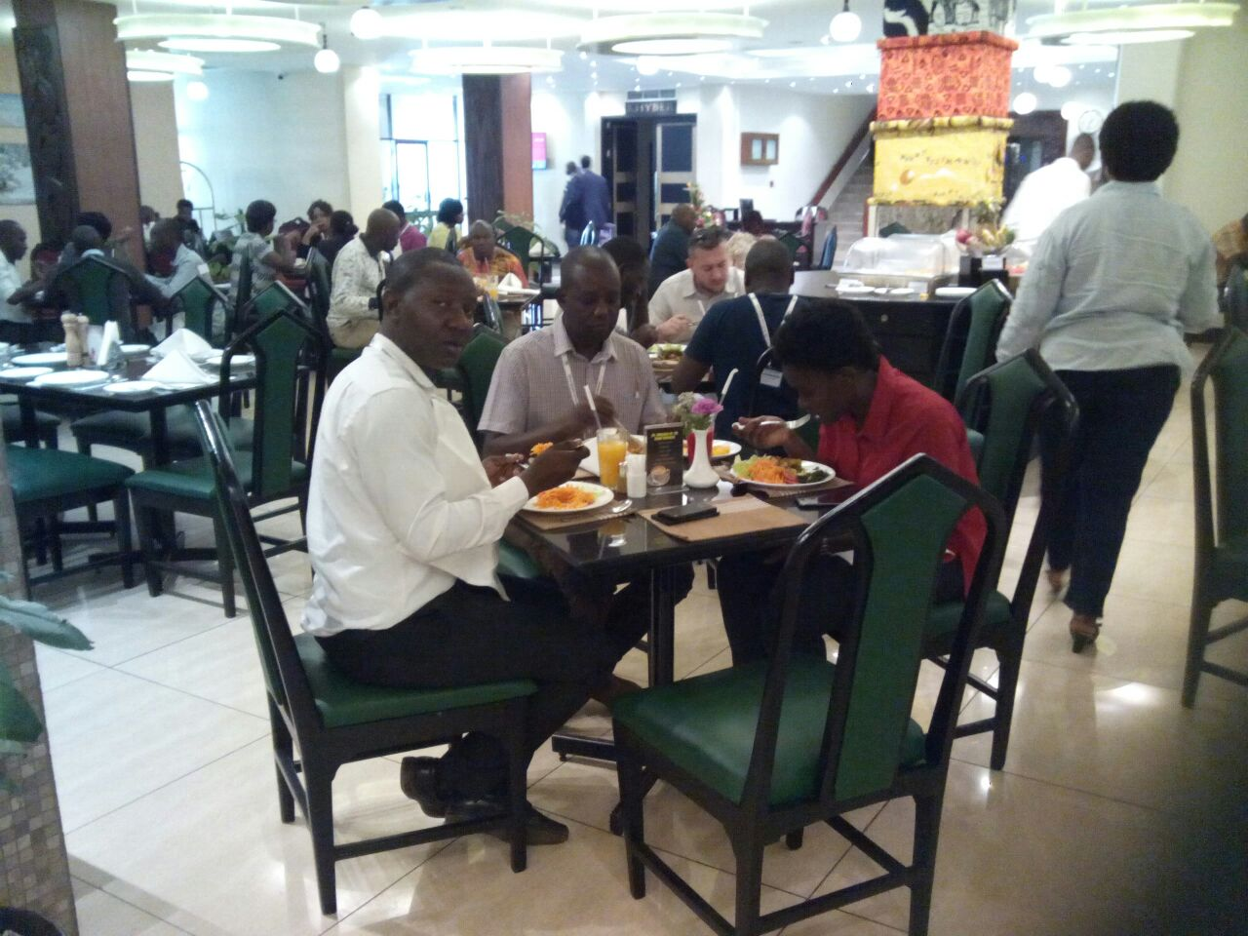

FAMILY DEVELOPMENT SERVICES

- Case Management and Counseling 178 adults received case management assistance 65 adults received individual counseling 43 attended FAL classes ,138 Seniors ages 60+ enrolled. (236 senior citizens Served/provided with an array of daily activities specifically designed to meet the social and physical needs of senior citizens:)

3. Interns 11 Bachelor’s and Master’s level social work and counseling interns contributed approximately 11,000 hours of service to SAF-Teso in child, family, and youth departments.

EDUCATION AND TRAINING (DEVELOPING LIFELONG LEARNING IMPROVING EQUAL ACCESS TO EMPLOYABLE SKILLS.

On August 17, 2016, SAF-Teso implemented a project Titled Improving skills levels and the adaptability of the workforce in ………………………………. In order to develop lifelong learning Improve equal access to employment. The objective was to support productivity and progression in employment by raising skill levels at the levels of basic skills and intermediate level skills, to tackle skills gaps and shortages, and to promote gender equality in employment.
Target Group: The project priorities was on raising skill levels of 76 school drop-outs, 45 out of school youth, 35 unemployed youth and help them adapt to change and to raise productivity. Target groups will be employees of all ages.

The main focus of the priority: will be to raise skill levels of those with skill levels below level 2, especially youth without basic numeracy and literacy skills to bring them to level 2 and above. A second focus was to increase adaptability and to raise skills at the higher end (up to level 4) to support the knowledge economy by working with higher skilled employees in sectors with identified skilled gaps or shortages or sectors facing structural change.
Youth facing specific barriers in accessing skills training, including women - especially people with disabilities, were targeted with specifically designed interventions. The Rationale for this was based on Investment in learning is more critical than ever in the context of the modern knowledge-based economy.
The identification of this need was based on the rate of economic and social change which is ever increasing, and also that people with no qualifications, low levels of skills or out-dated skills are at risk of failing to progress in employment or losing their jobs. The key characteristic of the region is the pronounced long tail of low skills compared to other parts of the country.
The Education and Training looks forward to raising the basic skill levels of the workforce and assist individual progression in employment to Level 2 by supporting interventions that ensure work-based learning provision that better meets the needs of employers and individual workers. In addition, targeted demand-led interventions to Levels 3 and 4, will be supported and specific attention will be given to supporting school drop-outs and unemployed youth to integrate more successfully into the local economy and society.
At a personal level: the acquisition of qualifications and basic, intermediate and higher level / graduate skills over a lifetime, is one of the key factors for securing a route into, and maintaining sustained employment. * Change has become a constant feature of economic life. Globalization, new technologies and demographic ageing will have increasing consequences for labour markets across Uganda, and therefore workers and enterprises need help in adapting to these changes. In addition, higher employment and productivity, competitiveness, better wages and working conditions directly depend on the ability of enterprises and workers to innovate and adapt to change.

Skills are therefore, crucial to business success, but in some sectors, or for some firms, there is a lack of suitably qualified applicants. Research indicates the sectors experiencing the greatest problems in terms of skills supply are production, construction, wholesale/retail and hotels/catering. The skills most lacking are problem solving, customer handling and other technical and practical skills such as ICT.
This project priority was designed to support activities which aim to address Recommendation of Uganda’s employment Strategy response of for the year 2020 to improve access to, and affordability of childcare and care for other dependants, increase access to training for low paid women in part-time work, and take urgent action to tackle the causes of the gender pay gap.
Further action is also needed to tackle barriers faced by individuals in taking up such opportunities, with particular attention needed for disabled people, particularly the youth. Despite progress over recent years, there remains significant gender inequality in employment in Uganda, in terms of economic activity, occupations and pay.
There is a complex and often highly debated mix of reasons for the current gender pay gap in Uganda and while career choice and human capital can be factors, some researchers believe that even once all explanatory factors are taken into account an unexplained gap of around 10% may exist. Women could be making a more significant contribution to tackling the skills shortages in industries such as construction and engineering, and in skilled trades, for example, electricians and plumbers.
Combating gender stereotypes within the school setting may also help with the struggle many bisexual pupils face in mainstream education. In addition, better general environmental awareness and environmental skills will become increasingly important in the face of increasing climate change and to exploit the opportunities presented by our natural environment.
This can be achieved by the integration of sustainable development principles into education and training programmes. Skills that improve resource efficiency will help to reduce carbon emissions and also reduce costs thereby improving competitiveness. Specialist skills that are needed include the sustainable management of natural terrestrial and aquatic resources, high standards of environment performance for buildings, environmental management for business and developing the environmental goods and services sector.

Policy Context Uganda This priority will address the employment recommendation to the UK in 2004 under the European Employment Strategy by supporting action to: * implement national and regional skills strategies to provide better incentives for lifelong learning and thereby increase productivity and quality in work; place particular emphasis on improving literacy and numeracy of the workforce, the participation and achievement of low skilled workers, especially those in poorly paid jobs.
* ‘improve access to and affordability of childcare and care for other dependents, increase access to training for low paid women in part-time work and take urgent action to tackle the causes of the gender pay gap.
DONORS
More than 1,000 individuals, couples, families, trusts, businesses, corporations, foundations, civic clubs, and churches supported SAF-Teso in the July 1, 2013–June 30, 2014 fiscal year. Support ranged from in-kind donations, capital campaign payments, and cash gifts to special event purchases, silent and live auction purchases, and government contracts.
Every effort has been made to reflect accurately each gift in a year of significant leadership and database changes. Sincere apologies are extended to any entity not accurately recognized. Please contact Emitu Joseph, Director of Advancement, at (256) 078407675 or safteso@hotmail.com to make any inquiries or corrections.
DONOR | PROJECT | AMOUNT | YEAR
Starkey Foundation | Hearing Aids |  | 2015

DISTRIBUTION OF HEARING AIDS TO THE DEAF.

In 2015, the hearing Aids Global Giant Starkey foundation donated an assortment of hearing aids worth 35,000,000 to 650 people a cross teso sub-region, including affected persons in the nearby districts of moroto and Bugisu sub-region. Below is the Pictorial outlook of the events/activities

CAPACITY BUILDING FOR SACCO-VSLA GROUPS
Village level Women Savings and Loan Groups were trained on financial management, basic book keeping, business selection and management, entrepreneurship, product marketing and risk management skills.
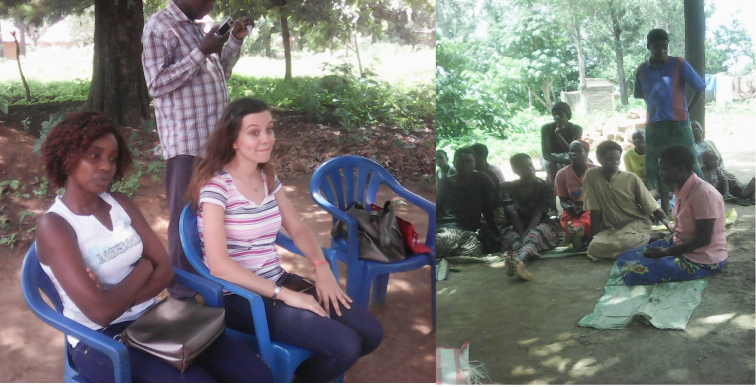

FAL (FUNCTIONAL ADULT LITERECY EDUCATION).
Functional Adult Literacy (FAL) evolved from the needs of those who missed the opportunity of formal education during childhood, especially for those who are searching for knowledge and skills that help them to improve on whatever activities they are engaged in for betterment of their lives and the communities where they live. The Functional Adult Literacy by SAF-Teso, aimed at providing skills in reading, writing and numeracy integrated with practical knowledge and skills.
FAL targeted a large range of people, including men and women, older people and youths, and specific groups of marginalized people such as prison inmates, those who are disabled and ethnic minorities.

A total of 60 women benefited from this project. See the pictorial outlook below:
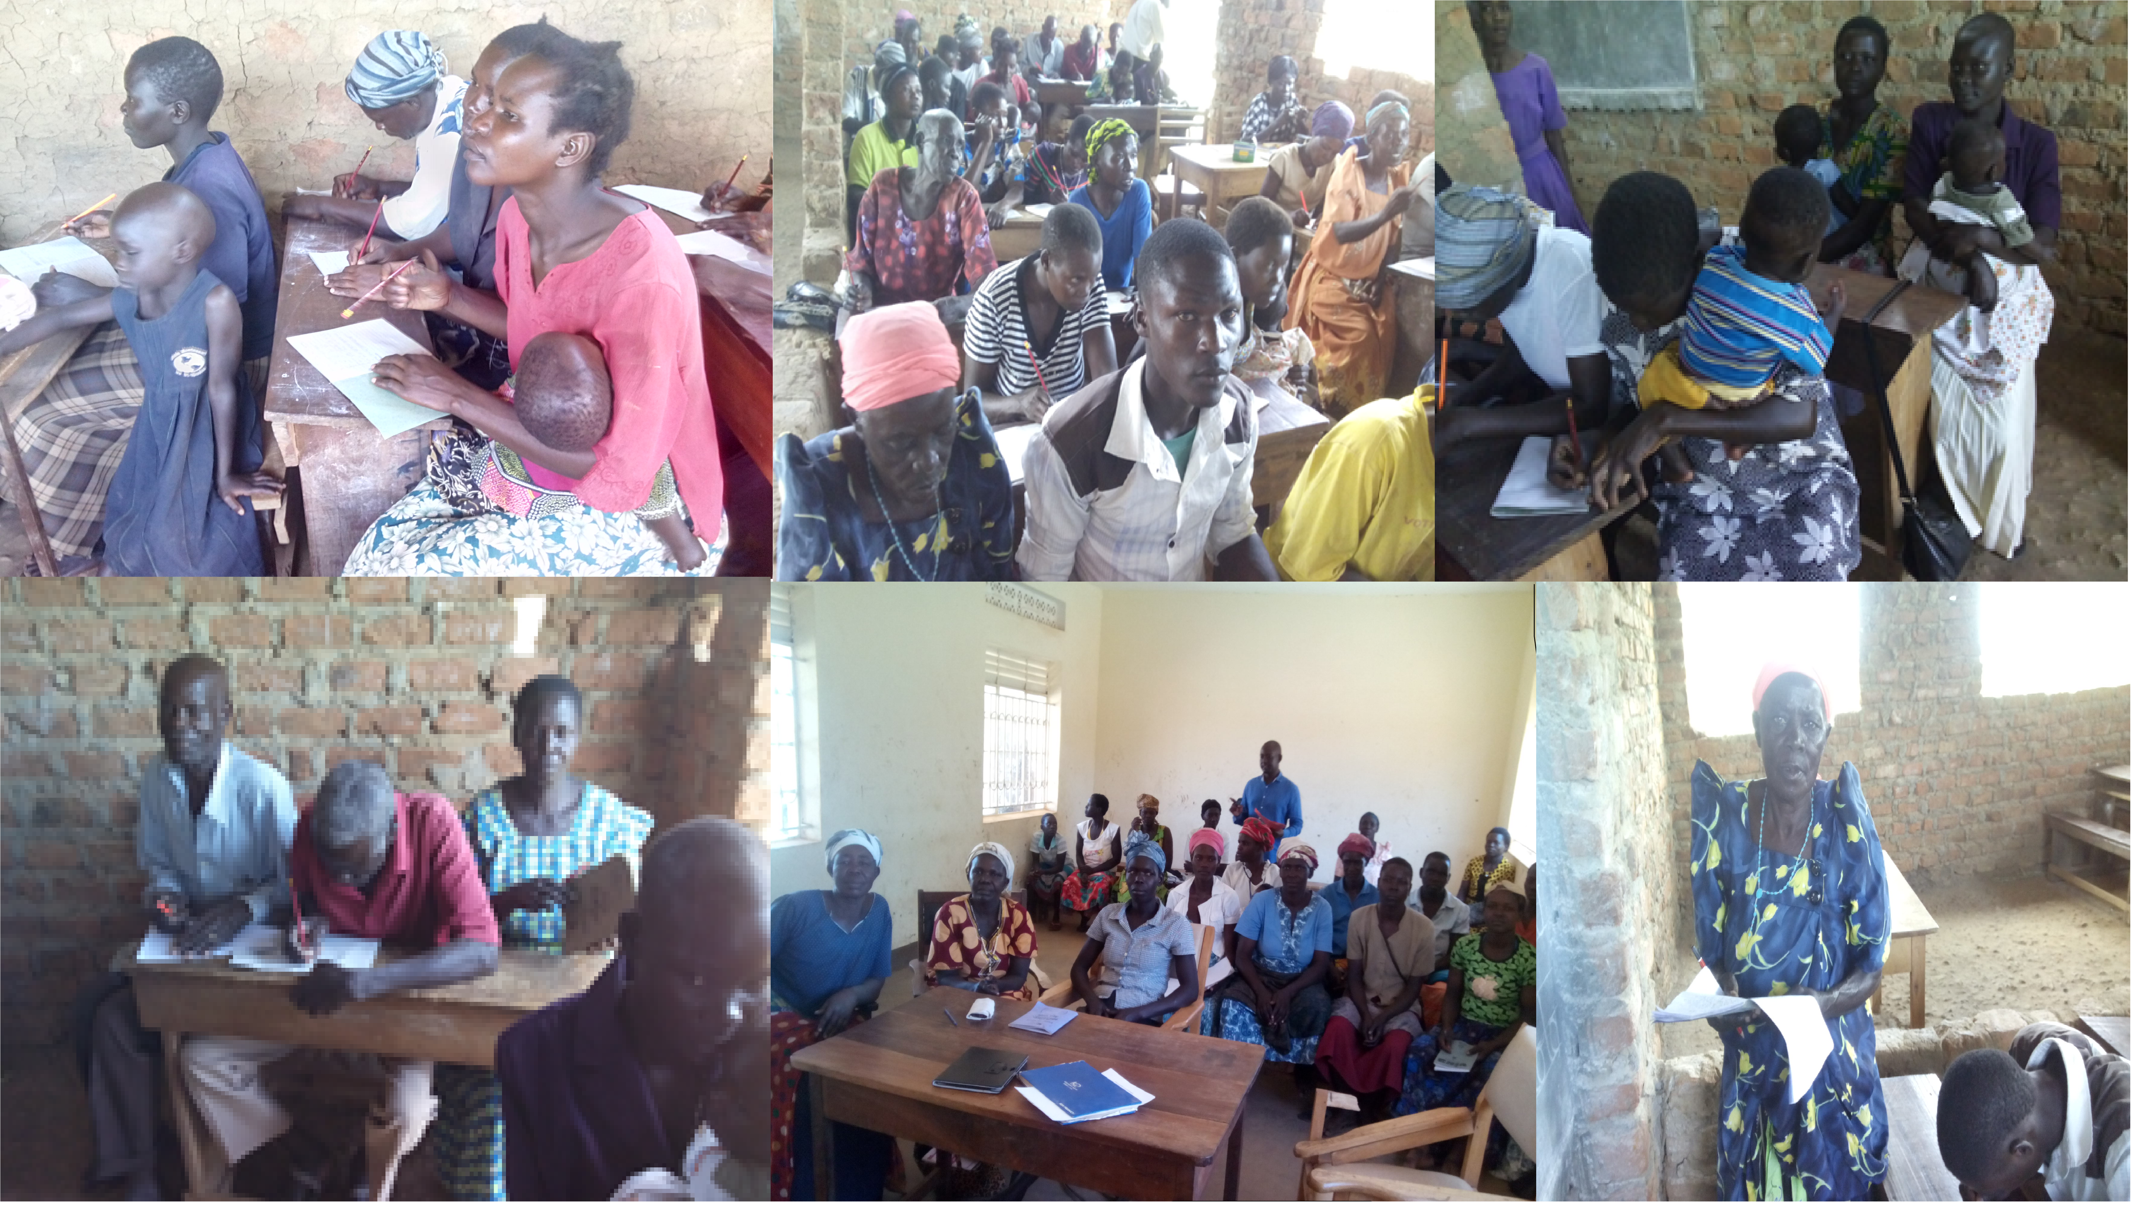

SOLAR POWER GENERATION/DISTRIBUTION PROJECT.
Pilgrim Africa, SAF-Teso and the Colombian University Engineers without boarders-USA have entered into agreement in order to undertake engagement in rural electrification program in Orungo sub-county, moruinera parish as a model.

